Running the Rabbit Jejunum Simulation

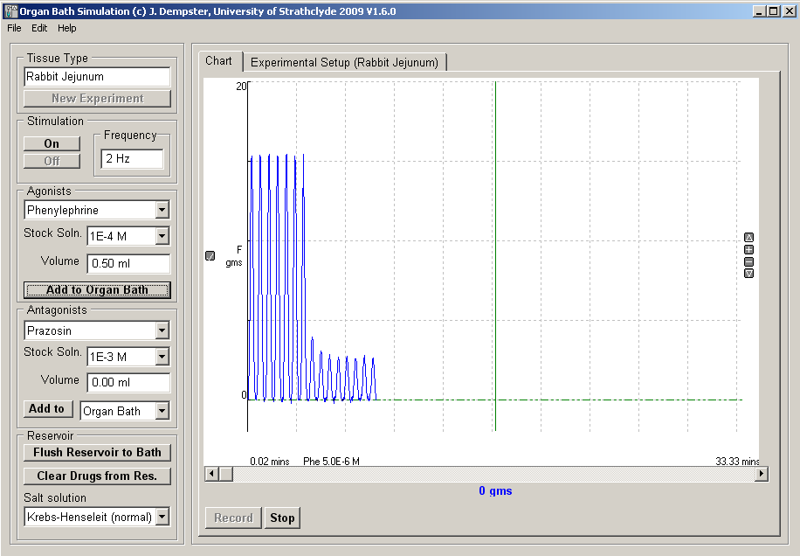
The Organ Bath simulation program allows you to perform simulated in vitro experiments on a range of different types of tissue.

To start the Organ Bath simulation program click on its icon in the Phys & Pharm folder on the Windows desktop.
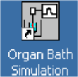

Starting a rabbit jejunum ring experiment
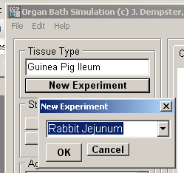
To start the simulated experiment:
- Click the New Experiment button
- Select Rabbit Jejunun from the list of experiments in the New Experiment dialog box. Then click the OK button.
- Click the Record button to start recording the tissue contractile force in the chart recorder window.
Note. Do not change the tissue type during the course of an experiment. You can also stop and re-start recording at any time using the Stop / Record buttons.

Applying agonists

Agonists are injected directly in to the organ bath which has a volume of 10 ml. There are two agonists available: phenylephrine and propranolol.

To apply an agonist:
- Select the type of agonist to apply from the Agonist list.
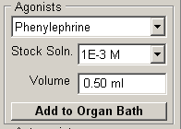
- Select the concentration of the agonist stock solution to be added from the Stock Soln. list.
- Enter the volume (0-1 ml) of stock solution to be added into the Volume box.
- Click the Add to Organ Bath button.
- Wait till the tissue response is observed.
The type and final bath concentration (FBC) of the agonist is marked on the chart recording. If desired, you can increase the bath agonist concentration by repeating steps (a-d).
Applying antagonists

Antagonists can be injected directly in to the organ bath or into the reservoir. In this experiment you will be adding the antagonists directly to the bath, after an agonist has been applied.

To apply an antagonist:
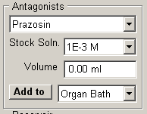
- Select the type of antagonist to apply from the Antagonist list.
- Select the concentration of the antagonist stock solution to be added from the Stock Soln. list.
- Enter the volume (0-1 ml) of stock solution to be added into the Volume box.
- Select Organ Bath in the Add to list.
- Click the Add to button.
- Wait till the tissue response is observed.
If desired, you can increase the bath agonist concentration by repeating steps (a-e).

Washing out

To remove any drug applied to the bath:
- Click the Flush Reservoir to Bath button to flush the bath with drug-free Krebs-Henseleit solution from the reservoir.

Stimulating the sympathetic nerves.

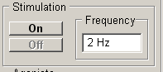
To stimulate the sympathetic nerves innervating the jejunum:
- Select a stimulation frequency (Hz)
- Click the On button.
- To stop stimulating click the Off button.

Measuring tissue responses

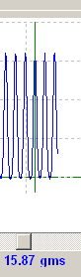
To measure the peak amplitude of tissue contractions:

- Click the Stop button to stop recording.
- Using the scroll bar at the bottom of the chart recorder display, select a section of the recording containing the tissue contraction to be measured.
- Drag the green vertical measurement cursor on the chart display to the point on the recording trace to be measured. The contractile force at the cursor point (in units of gms.) is displayed below the cursor. Note that you can also move the cursor left and right in small steps using the left and right arrow keys.

Printing and copying chart recordings

To print a copy of the displayed chart recording on a printer, select Print from the File menu.
To copy the data points of the displayed chart recording to the Windows clipboard for pasting into a spreadsheet or graph plotting program, select Copy Data from the Edit menu.
To copy the a picture of the displayed chart recording to the Windows clipboard for pasting into a Word document or a PowerPoint presentation, select Copy Image from the Edit menu.

Saving and re-loading chart recordings

To save the current chart recording for the current experiment to a data file, select Save Experiment from the File menu and enter the name of a new data file.
To load a previously saved chart recording from a data file, select Load Experiment from the File menu and enter the name of the data file.

